Tutorial ME 6205 Thermodynamics
Fundamental Concepts of thermodynamics
A certain amount of air is compressed in a cylinder. The change in internal energy of the air is 10kJ. Work required for the compression is 500kJ. What is the amount of heat transfer?
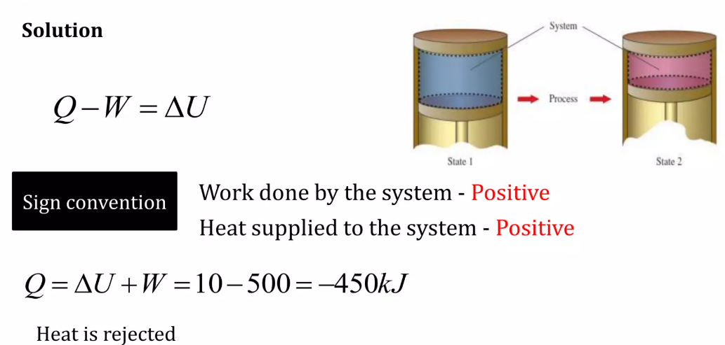
A 0.6kg copper piece at 100oC is dropped in to an insulated tank containing 0.75kg of liquid water at 25ºC. Determine the temperature of the system when thermal equilibrium is reached. Specific heats of copper and waterare:0.393kJ/kgK and 4.184k/kgK.
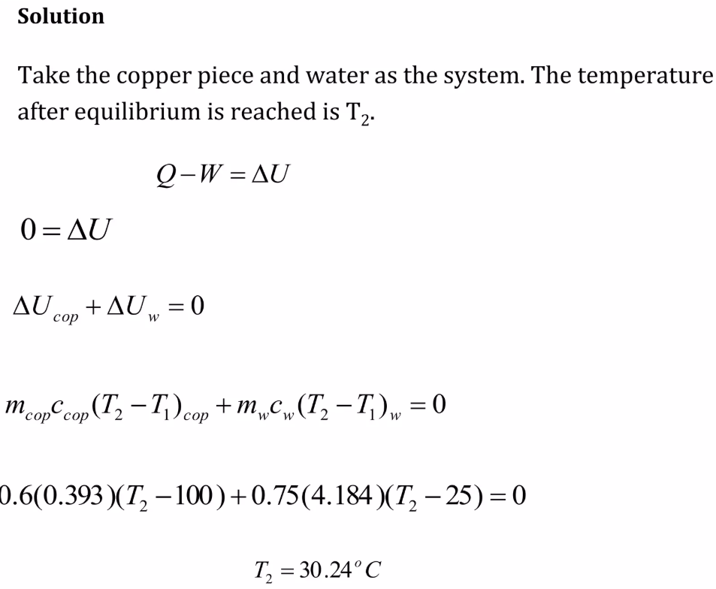
The temperature of 3.5kg of gas in a container is increased from22oC to 39oC by heating it. The heat transferred during the process is 25k]. Calculate, treating the gas to be a perfect gas, (a)change in internal energy and (b)work done
The specific heats ratio and the molar mass of the gas are 1.4 and28g respectively.
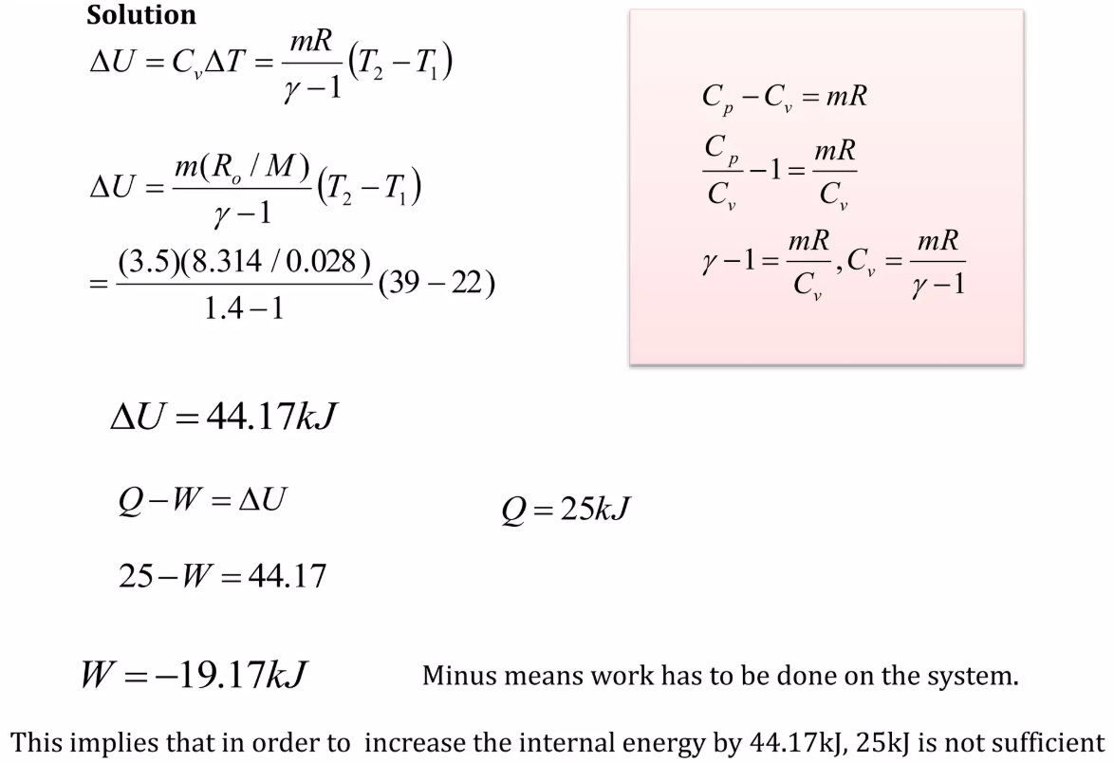
An insulated cylinder closed at both ends contains free moving piston. One side of the cylinder is filled with nitrogen, and the other side with air. Initial pressure and volume of each gas are 1bar and0.01m³ respectively. The initial temperature is 20ºC for both the gasses. The air in the cylinder is heated by means of an electrical heater installed inside the cylinder until the volume occupied by the nitrogen is reduced to 0.008m³. Find (a) final temperature of air and (b) Work done by air (c) heat added to air
(C_{v} for air is 0.718k/kgK and R for air is 0.287k]/kgK. Adiabatic index for nitrogen is 1.4)
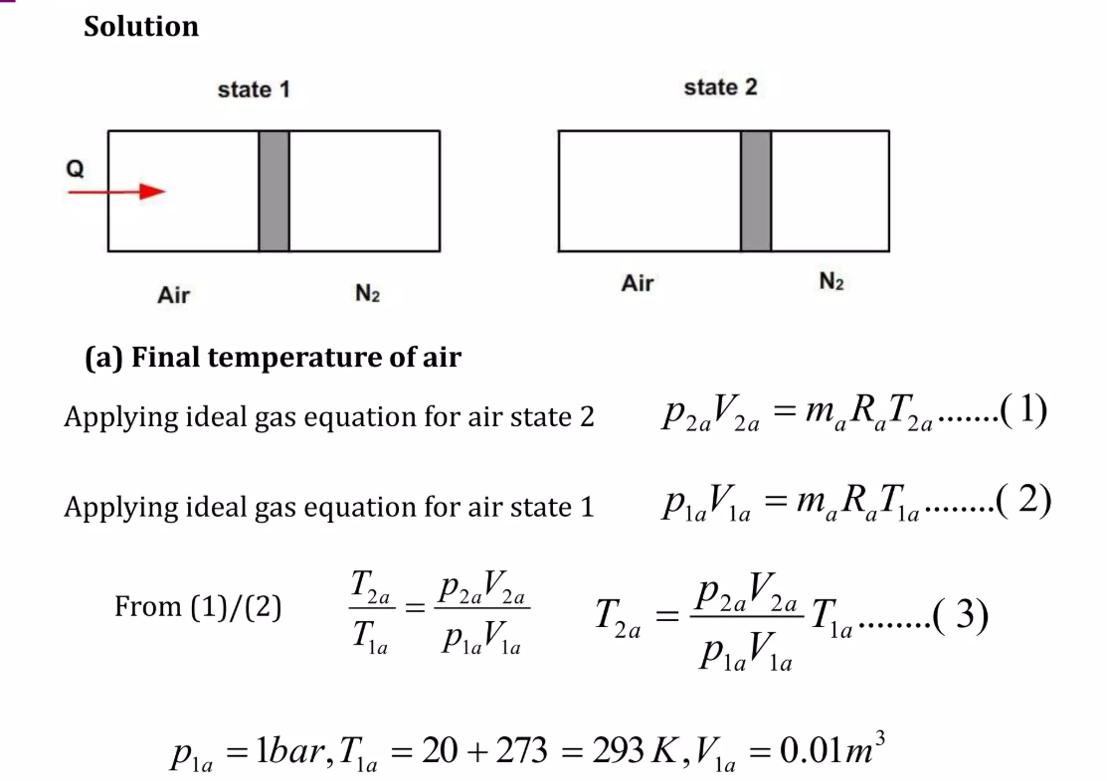
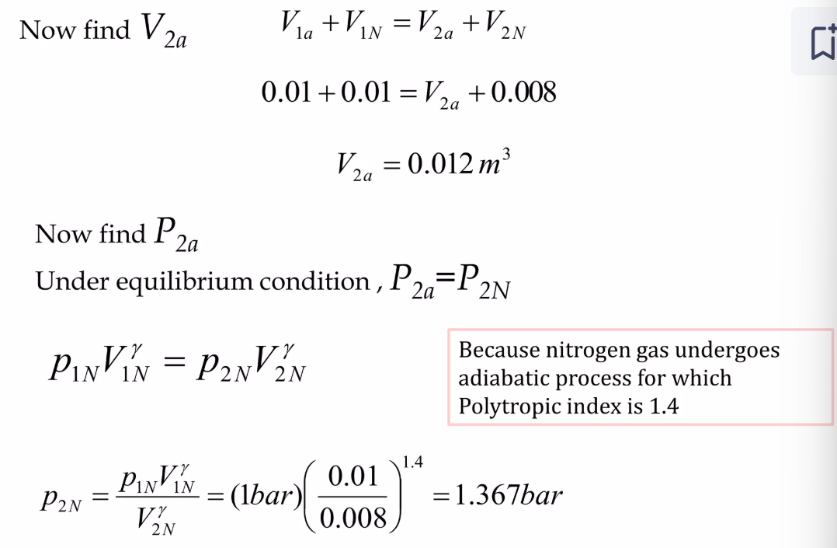
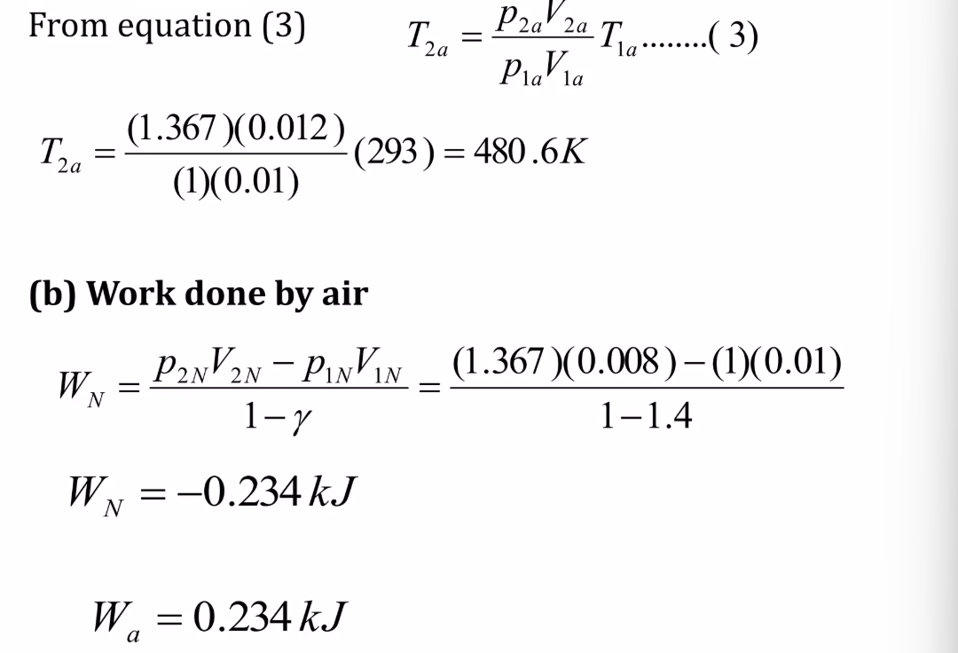
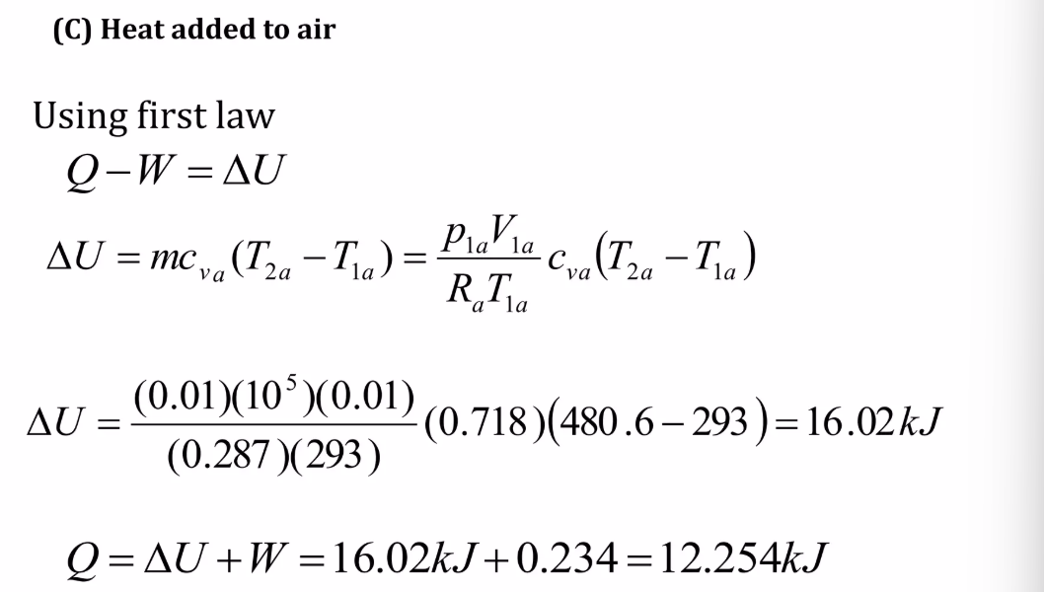
In a piston cylinder device, 300g of saturated water vapor maintained at 200kPa is heated by a resistance heater installed within the cylinder for 10min by passing current of 0.35A from220V source. The heat loss from the system during the heating process is 2.2kJ. Calculate (a)final temperature of the steam(b) work done.
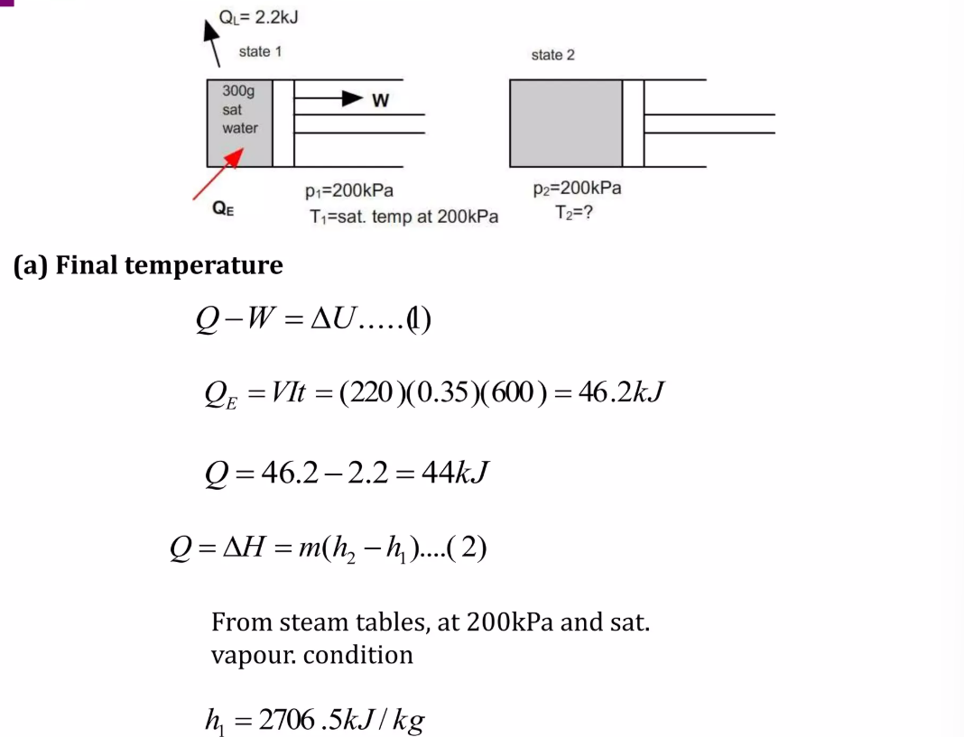
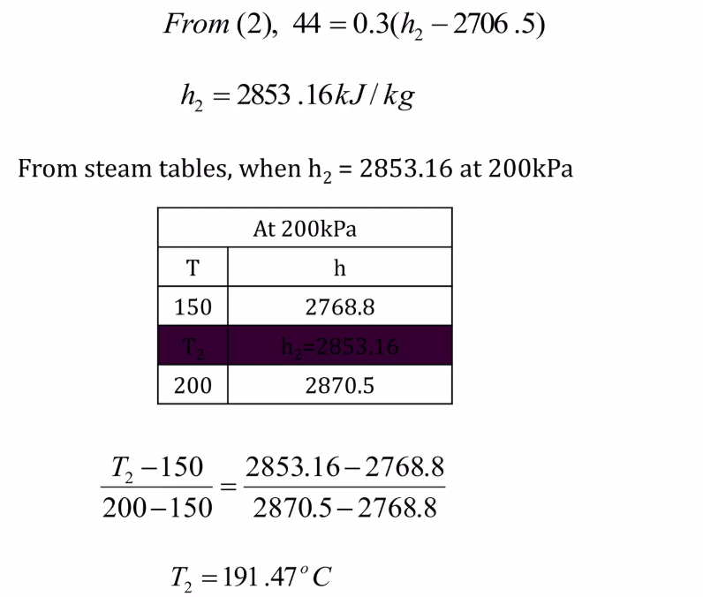
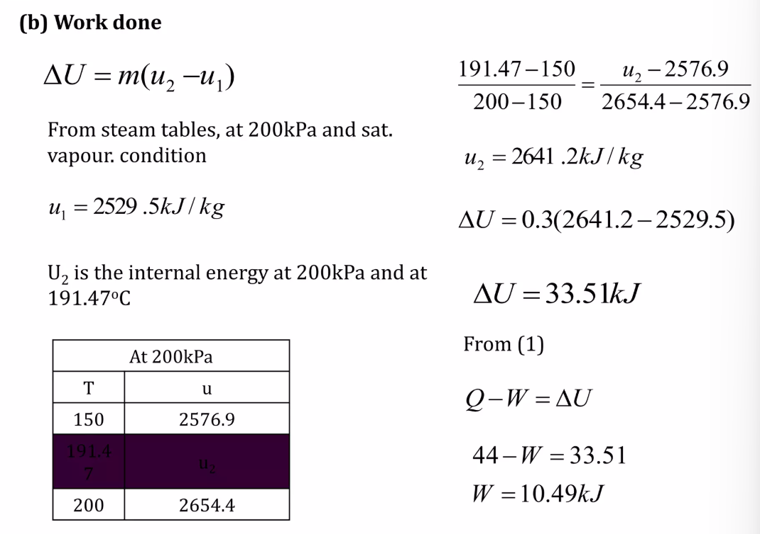

Laws of Perfect Gases
1: Determine the volume of occupied by 2.34 grams of carbon dioxide gas at STP.
Solution:
1) Rearrange PV = nRT to this:
V = nRT / P
2) Substitute:
V = [(2.34 g / 44.0 g mol¯¹) (0.08206 L atm mol¯¹ K¯¹) (273.0 K)] / 1.00 atm
V = 1.19 L (to three significant figures)
2: A sample of argon gas at STP occupies 56.2 liters. Determine the number of moles of argon and the mass of argon in the sample.
Solution:
1) Rearrange PV = nRT to this:
n = PV / RT
2) Substitute:
n = [(1.00 atm) (56.2 L) ] / [ (0.08206 L atm mol¯¹ K¯¹) (273.0 K)]
n = 2.50866 mol (I'll keep a few guard digits)
3) Multiply the moles by the atomic weight of Ar to get the grams:
2.50866 mol times 39.948 g/mol = 100. g (to three sig figs)
3: At what temperature will 0.654 moles of neon gas occupy 12.30 liters at 1.95 atmospheres?
Solution:
1) Rearrange PV = nRT to this:
T = PV / nR
2) Substitute:
T = [(1.95 atm) (12.30 L)] / [(0.654 mol) (0.08206 L atm mol¯¹ K¯¹)]
T = 447 K

https://www.svce.ac.in/wp-content/uploads/2023/02/mech/ME18401-TE.pdf

